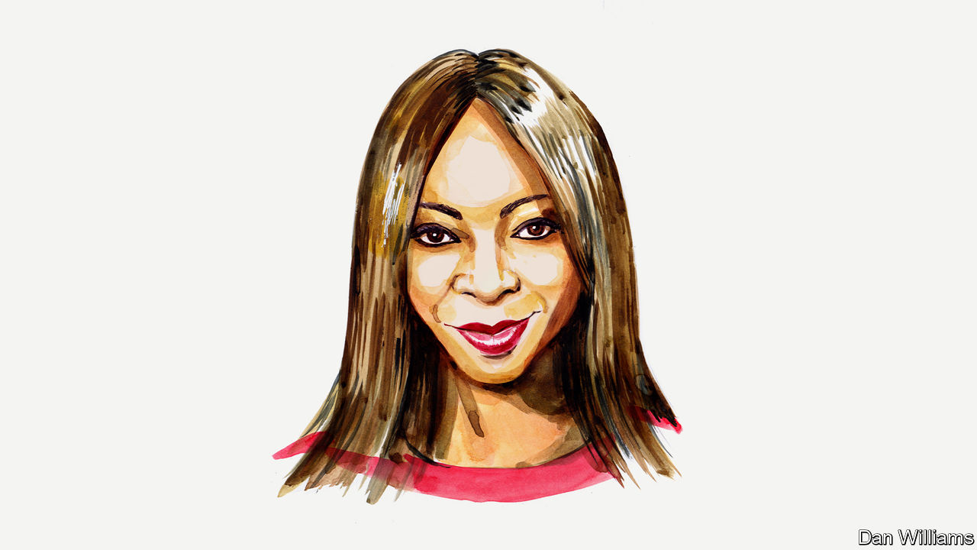

The world after covid-19
Dambisa Moyo on a “Marshall Plan” for Africa
America and Europe should provide direct cash transfers to Africans to alleviate the covid crisis
May 5th 2020
BY DAMBISA MOYO
THE PANDEMIC’S scale and virulence means it is destroying economies as much as it is claiming lives. Poor countries look as if they will suffer the worst, in particular those in Africa, home to the most impoverished. But the world need not be passive in the face of the calamity. A modern “Marshall Plan” for Africa, modelled after the big aid package that America provided European countries after the second world war, could prevent a humanitarian tragedy and pay dividends for generations.
A decade ago I gained notoriety as a critic of large-scale foreign-aid programmes that flow from Western countries to developing economies. I argued that over $1trn of aid provided over the previous 60 years had failed to improve living standards across Africa. I argued that, worse still, it had harmed, not helped, the continent by fuelling corruption, fostering dependence and creating economic malaise.
Yet today it is clear that Africa urgently needs a substantial aid injection or it will be destroyed by the coronavirus. There are three broad reasons to act.
First, morality. If nothing is done, Africa is forecast to have as many as 1.2bn infections and 3.3m deaths by the end of 2020, according to the UN Economic Commission for Africa. Second, migration. Aid may prevent a surge in disorderly or illegal migration, which is already plaguing Europe. If Africa’s health infrastructure and economic foundations are not stabilised, the pandemic will almost certainly unleash an exodus of refugees.
The third reason is, frankly, influence. At a time when China is the pre-eminent geopolitical force in Africa, a large aid package is an opportunity for the West to re-engage with the continent and gain a new edge in its ideological and commercial clash with China. This mirrors how America was motivated to create the original Marshall Plan to prevent Europe tilting towards the Soviet Union.
Already China has proven a worthy contender in this great-power rivalry, as a partner with Africa in trade, investment and aid. China’s exports to Africa topped $90bn in 2018, three times those of America. Meanwhile, China is a leading investor in the African continent. In 2018 Chinese flows of foreign direct investment into Africa reached $5.4bn, whereas flows to the continent from America have remained consistently below $2bn since 2015 and turned negative in 2016 and 2018. Considerable support by the West may prevent Africa from pivoting further towards China.
That is the lesson of the original Marshall Plan. From 1948 to 1952 America provided loans, grants and technical assistance to 16 European countries. The idea was to reconstruct cities, industries and infrastructure damaged during the war; to foster trade between Europe and America; and, crucially, to stem the spread of communism. The price tag was roughly $13bn, or around $135bn in today’s money.
This would hardly be enough to combat covid-19 across the continent. An alternative benchmark is the size of the Marshall Plan relative to the national economy. The $13bn in 1948 represented around 4.7% of America’s economy. To spend the same proportion today would cost around $1trn. That is roughly one-third of Africa’s overall gross domestic product, an amount in line with the scale of the problem, albeit ambitious. In contrast, the IMF and the World Bank have pledged $62bn in emergency financing for coronavirus for low-income and emerging economies—a hefty sum, but a fraction of what is probably needed.
America needs to lead. It can act faster than the European Union. And the dollar, as the world’s reserve currency, gives it flexibility in managing the fiscal burden. But European countries should not be far behind in giving support. After all, they are closer to the problems that disorder in Africa may bring.
In the spirit of the stimulus approach used in Hong Kong and in America (think the $1,200 cheques to its lower-income citizens), donor countries should consider direct cash payments to African households. The beauty of a direct-transfer approach is that it mitigates the risk of funds being illicitly diverted, as billions in aid have been before, despite all the “conditionalities” that are regularly imposed to prevent this. A payment infrastructure already exists. According to the World Bank, African citizens received $46bn in remittances in 2018. Moreover, donors can take advantage of technologies to make peer-to-peer transfers, such as via mobile phones.
The logic for the package is compelling. Africa is at the frontier of power politics, with its vast mineral resources and a substantial amount of untilled arable land on the planet. A Western aid project would be a counterweight to China’s influence and may pay itself back in security and economic terms, thus serving the West’s interests.
Like the original Marshall Plan, it would encourage the development of markets. American exports to Africa totalled just $28bn in 2018 while the EU exported nearly $170bn to Africa. The initiative would support a global, liberal, economic order of cross-border trade, international capital flows and market capitalism.
To some a Marshall Plan for Africa might appear fanciful and even seem a political non-starter, given the huge debts from stimulus packages and the nationalist political forces facing many Western governments. However, the risks of inaction are great, too: entrenching Africa’s poverty, fanning mass migration, fomenting domestic unrest and possibly terrorism, and pushing the continent closer to China. The economic harm of doing nothing may be costlier than intervening.
Of course, Africa was mired in problems even before the pandemic. The pace of poverty reduction is slowing. A population explosion is under way, with Africa’s population expected to double to 2.5bn by 2050. A lack of basic infrastructure such as roads, power and water hobbles economies. The consequences of climate change are largely overlooked (as they are basically everywhere). Growing debt weighs on national budgets. A Marshall Plan for Africa can’t fix every problem. But it might remedy the most urgent ones at a time when it is most needed.
To be clear, I am not advocating an open-ended aid programme in perpetuity. More than 60 years after the Bretton Woods agreement and the establishment of a system to provide international economic assistance, valid questions remain about its efficacy—not least because of African governments’ poor record in improving people’s lives and livelihoods at scale and in a sustainable way.
However, I advocate a Marshall Plan for Africa because it, like the original Marshall Plan—or any emergency aid for that matter—is short, sharp and finite assistance to save lives and rebuild the economy. It will save Africa, a continent that is home to more than one-fifth of humanity. And the West may reap the benefits for decades, too.■
Dambisa Moyo is an economist. Her books on global economics include “Dead Aid” (FSG, 2009). She serves on the boards of several companies, including Chevron and 3M.

