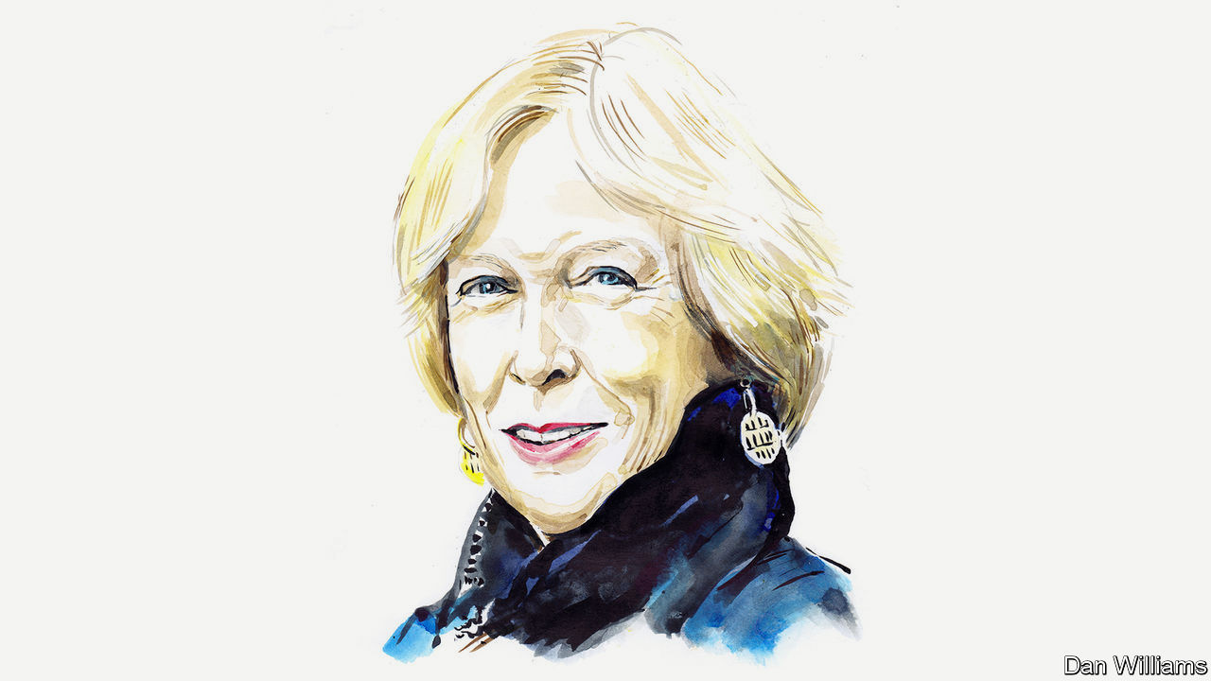

The world after covid-19
Margaret MacMillan on covid-19 as a turning point in history
The pandemic exposes our weaknesses and strengths. How the story unfolds will depend on leaders
By InvitationMay 9th 2020 edition

May 9th 2020
In the winter of 1788-89, the desperate government of Louis XVI asked the French people to send in lists of their grievances. It was a fatal mistake. The cahiers de doléances served to articulate the public’s unspoken discontent and, equally important, its hopes for a better world. A crucial psychological barrier had fallen: it became possible to imagine a very different France. And the times—the moral and actual bankruptcy of the Ancien Régime, widespread crop failures and hopeless leadership—gave shape to the public’s aspirations. The fuse was lit for revolution.
France in 1789. Russia in 1917. The Europe of the 1930s. The pandemic of 2020. They are all junctures where the river of history changes direction. The covid-19 crisis may be a pivotal rather than a revolutionary moment but it, too, is challenging the old order. Like France’s cahiers, the coronavirus forces questions about what sort of future we want, what the proper role of government is and what makes a healthy society. We face a choice: to build better ways of dealing domestically and internationally with this challenge (and prepare for inevitable future ones) or let our world become meaner and more selfish, divided and suspicious.
Long before covid-19, popular thinkers like Thomas Piketty, the late Tony Judt and Paul Krugman were warning about deep social inequalities and the shortcomings of globalisation. There were sporadic protests like Occupy Wall Street or France’s gilets jaunes. Most of us (such is human nature) carried on living. We worried from time to time about climate change, that our children couldn’t afford houses and that there seemed to be more obscenely rich people along with more homeless ones. Covid-19 has turned a spotlight on the dark sides of our world. We have become aware of the fragility of international supply lines, the disadvantages of offshore sources for critical goods and the limits of international bodies. The chaotic responses and blame games of certain governments have exacerbated divisions in and among societies, perhaps permanently. America has withdrawn from moral and material leadership of the world. It and China have grown more hostile to one another, not less. Rogue states such as Russia gleefully make more trouble and the un is increasingly marginalised.
When you name things—grievances, say, as the French did—you give them form and make it harder to ignore them. We are doing that now with the flaws in our world and spelling out our hopes for something better. As the French looked at Britain and America as models, we can see that South Korea, Denmark and New Zealand have controlled the pandemic more effectively than other countries, in part because their peoples have faith in the authorities and each other. Without trust—that the water is clean, medicines are safe, or thugs won’t get away with it—societies are vulnerable. Covid-19 has caused fewer deaths proportionately in Germany than elsewhere because of the country’s well-funded health system and its competent state and federal governments. As history shows, those societies that survive and adapt best to catastrophes are already strong. Britain rose to the challenge of the Nazis because it was united; France was not and did not.
Much also depended then, and depends now, on leaders. As weaknesses are exposed, do leaders fix or exploit them? While Franklin Roosevelt was promising Americans a better tomorrow in the 1930s, Adolf Hitler was destroying the Weimar Republic and intoxicating Germans with promises of revenge for the Treaty of Versailles. As we know, that ended in a world war.

